Dual-boot exercises

1

* I create a new virtual machine

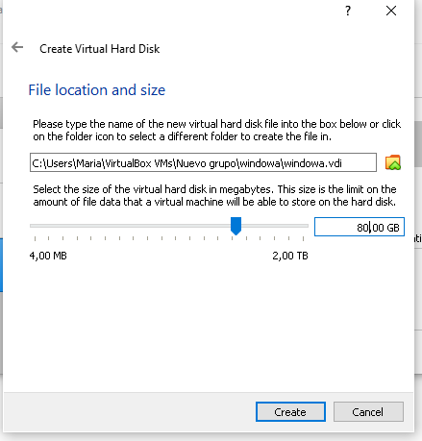

* After that I add the Windows 7 ISO file to install it first
* And I chose the correct languages

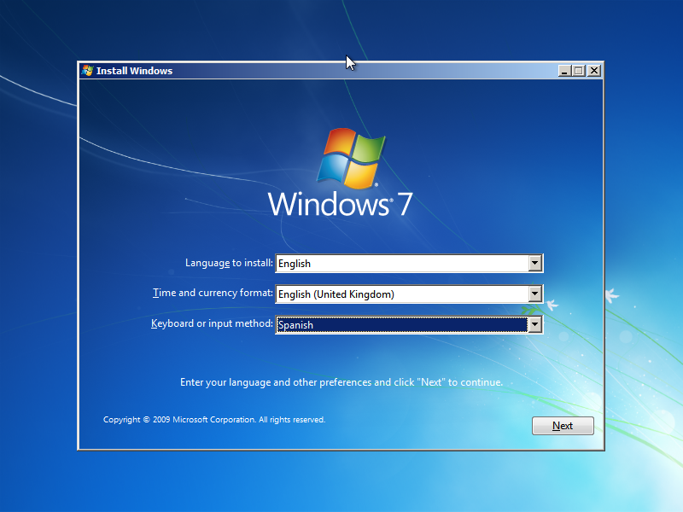

* I create a partition to repart the space in the disk between the two opertative systems that we need

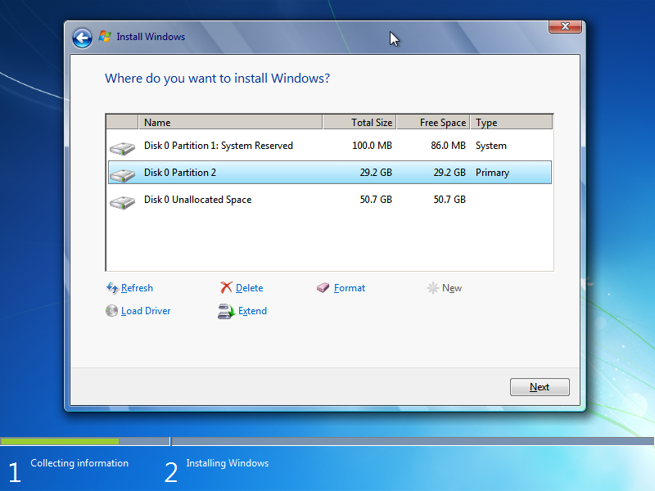

* I have to insert the username and password

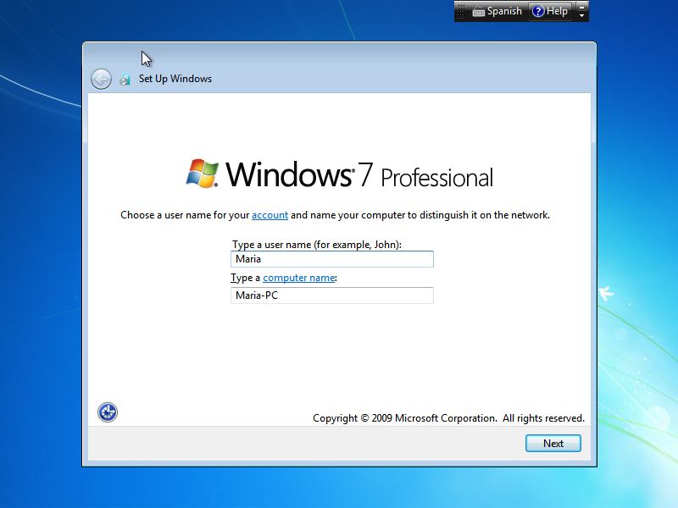

* Then you can install Windows 7

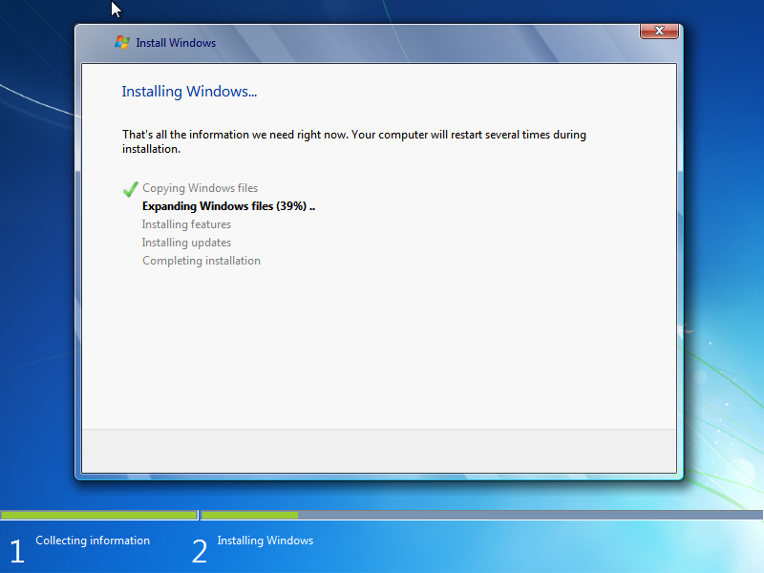

* After that I insert the Guest additions

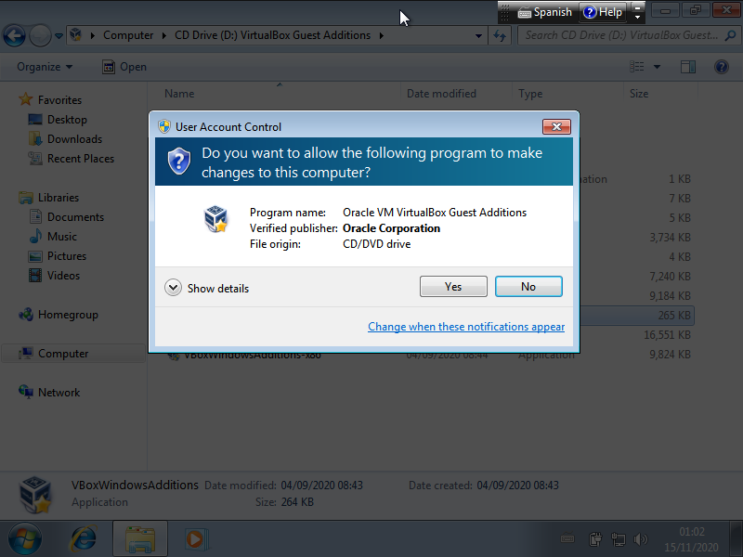

* After that I change the ISO file from Windows 7 to Windows 10 and I make the same process

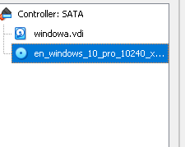

* I change the language but I make the screenshot before so It doesn´t appear, I put it in English but the keyboard I put it in Spanish

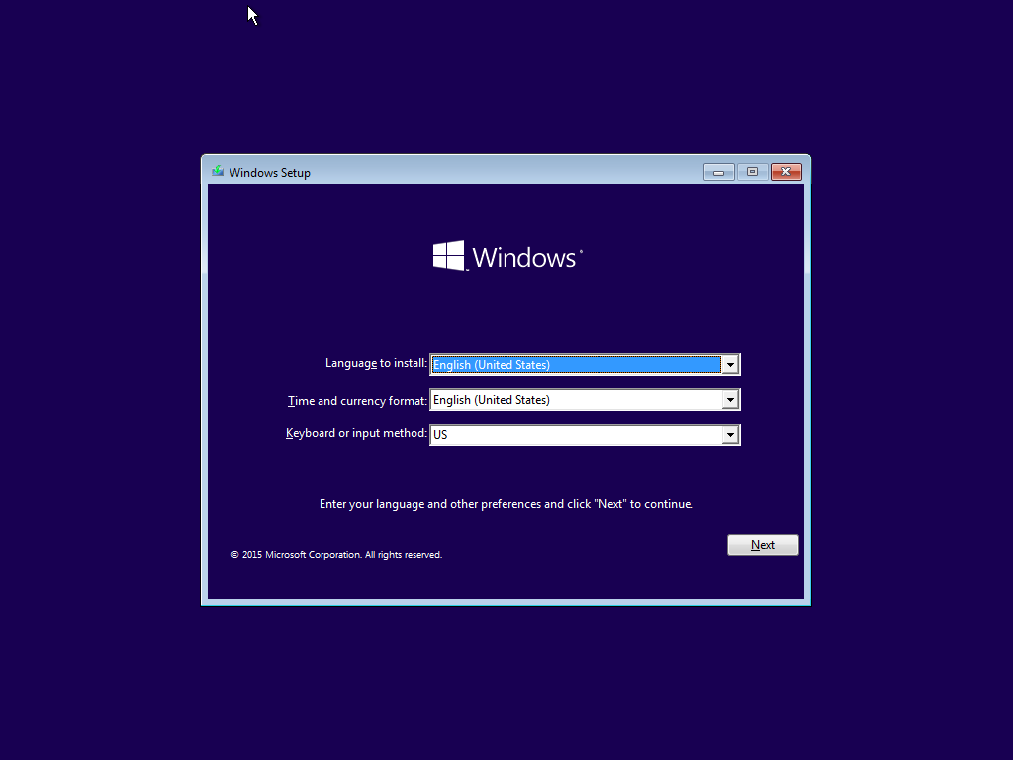

* I create another partition to have enough space in this operative system

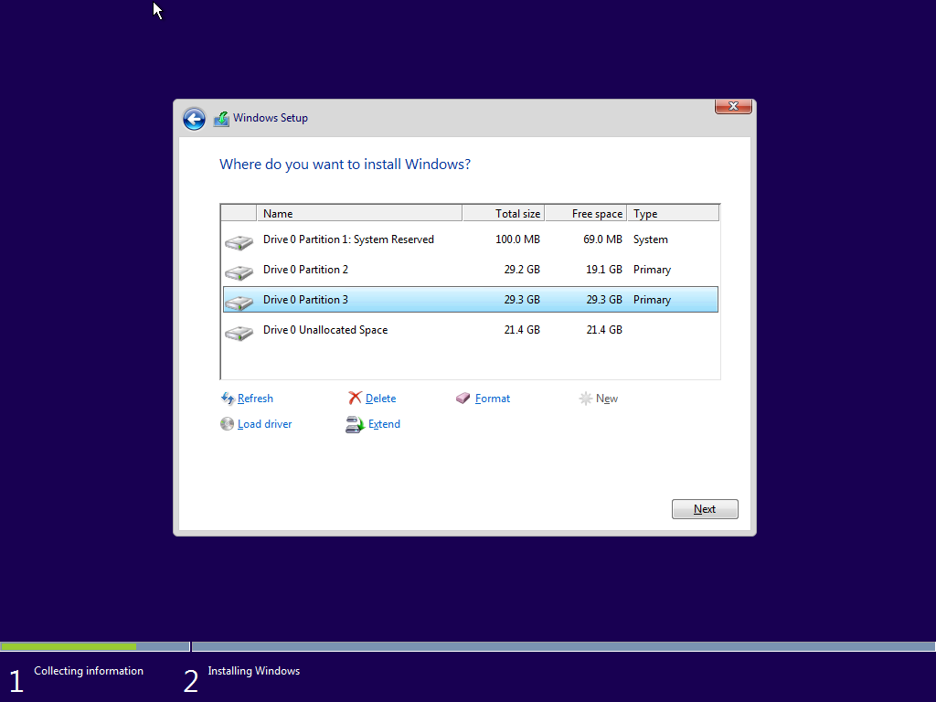

* And I have to put again a username and a password

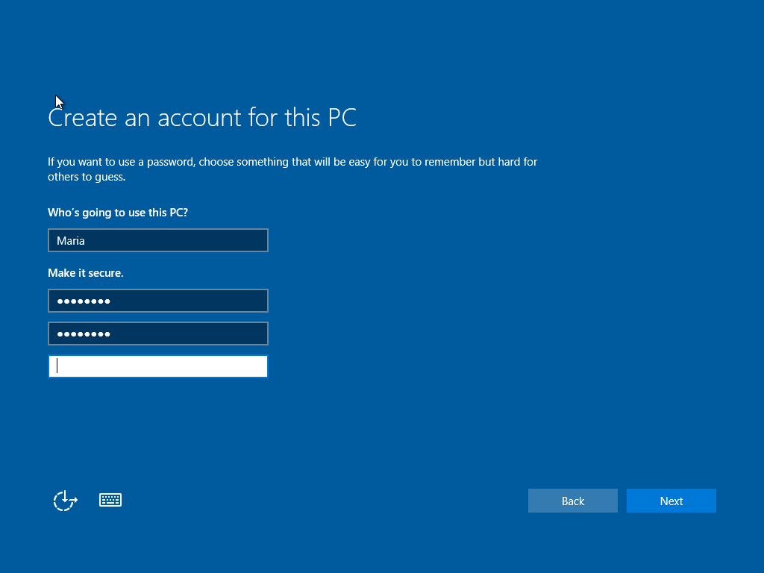

* Finally Windows 10 is also installed

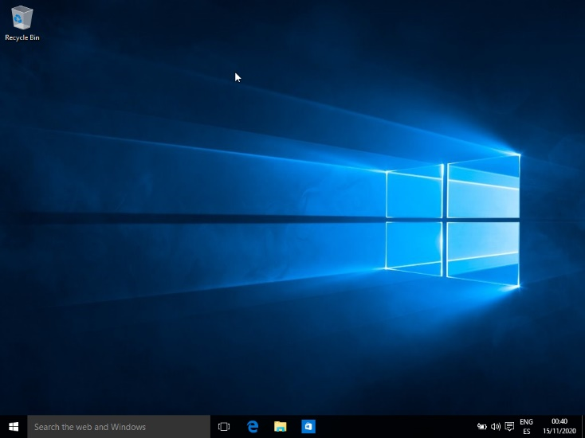

* Once you run the virtual machine with the two operative systems installed on it as a result you would have Windows 10 as a default operative system and if you don’t chose another one in a certain period of time it would run by it self.

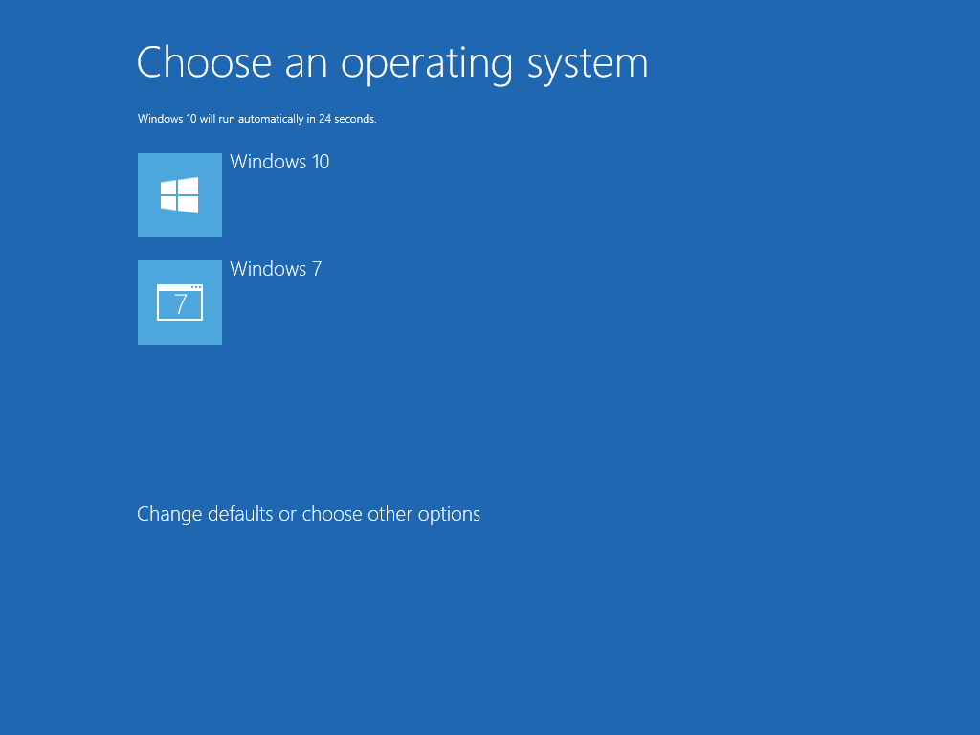

* I click on change defaults or choose other options
* And then I chose to change the default opertive system.

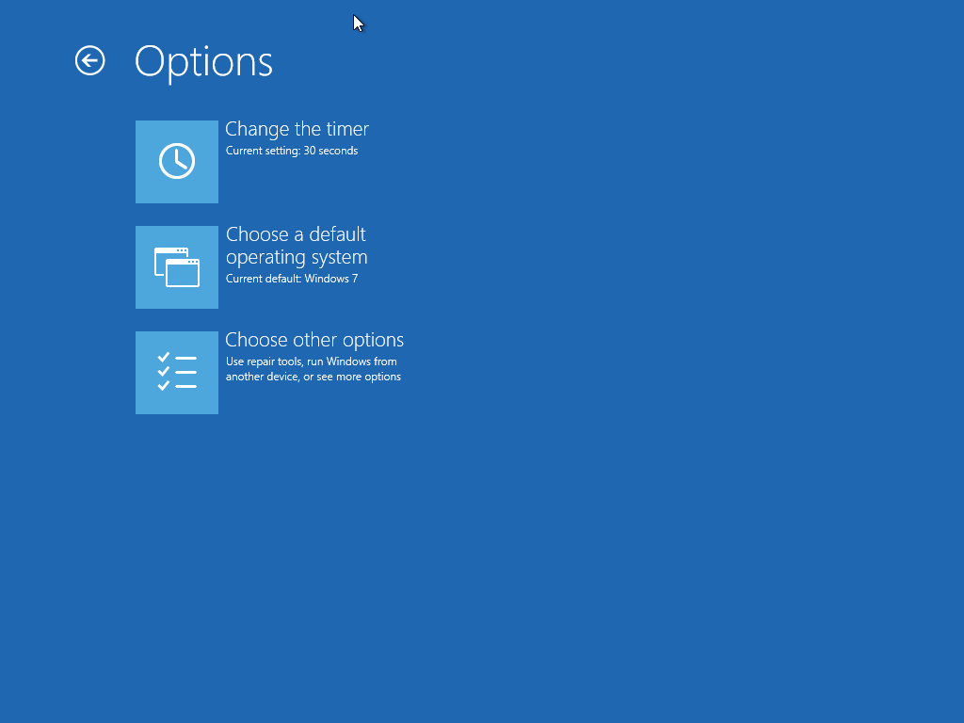

2

* I have installed Windows 10 and Ubuntu in the same virtual machine
* I insert the correspondent ISO in this case Windows 10

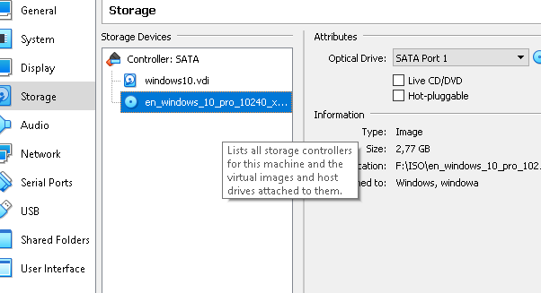

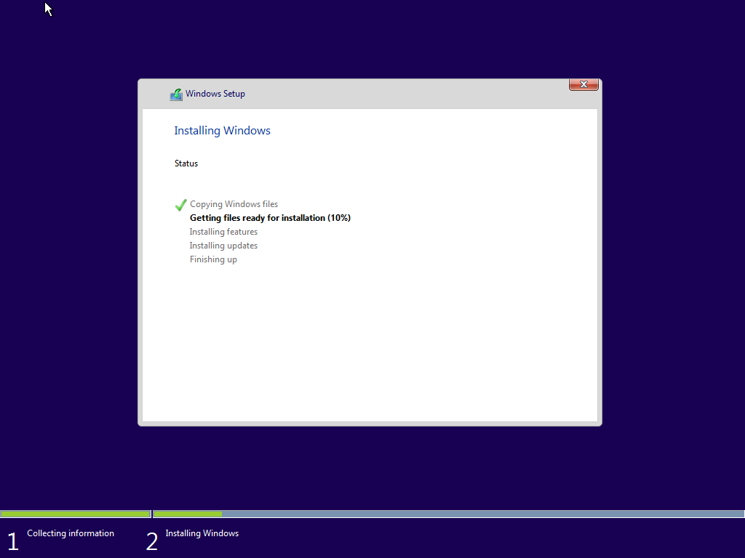

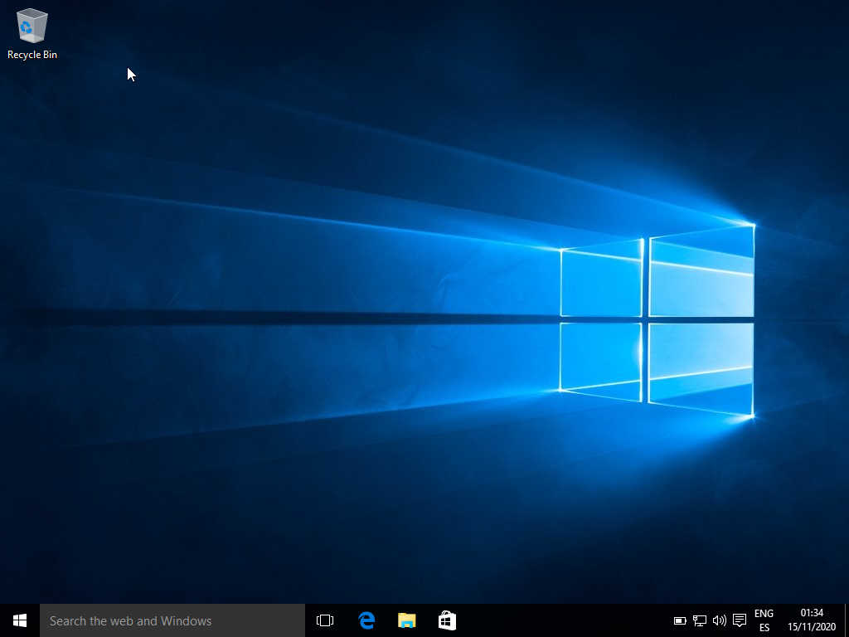

* When it has finished, I started with Ubuntu installation
* In this case I insert Ubuntu ISO

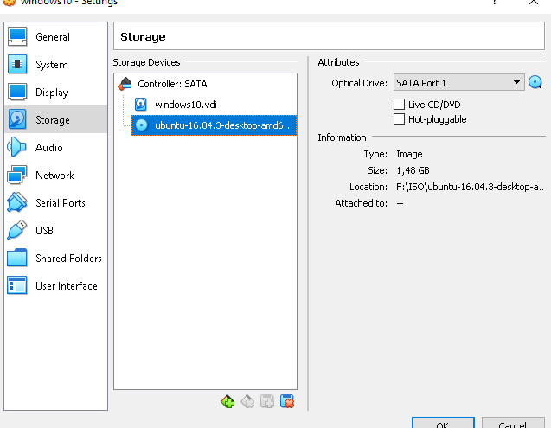

* I made all the necessaries partitions

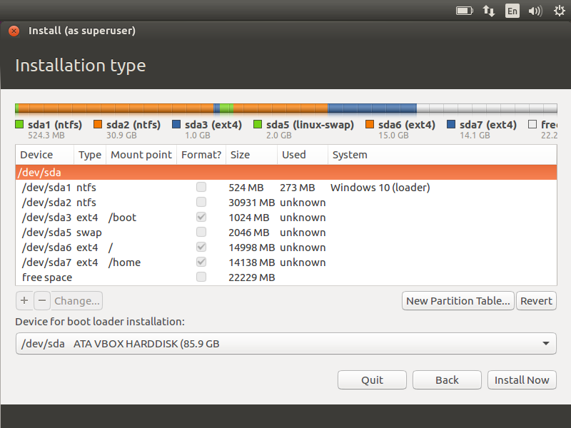

* And I create my own user

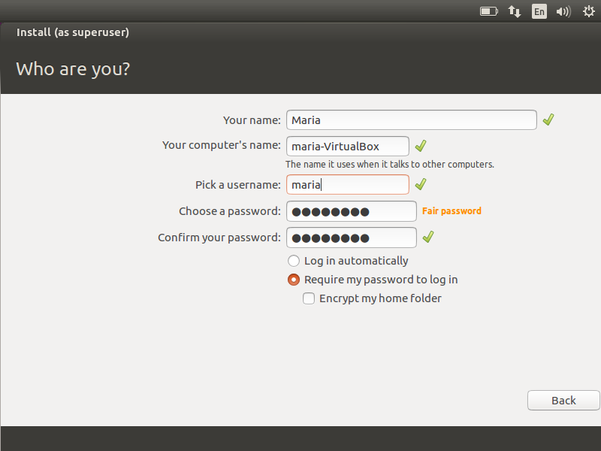

* I put my password

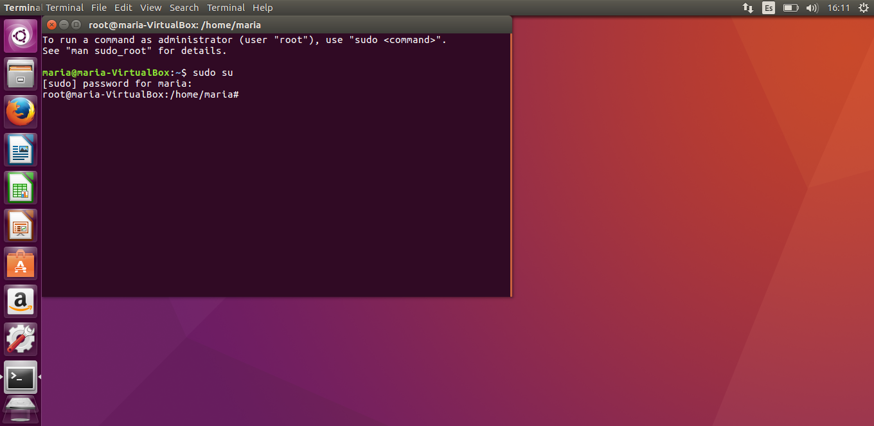

* And now I can start modifying the things I need to complete the statement

1. First of all I introduce nano /etc/default/grub

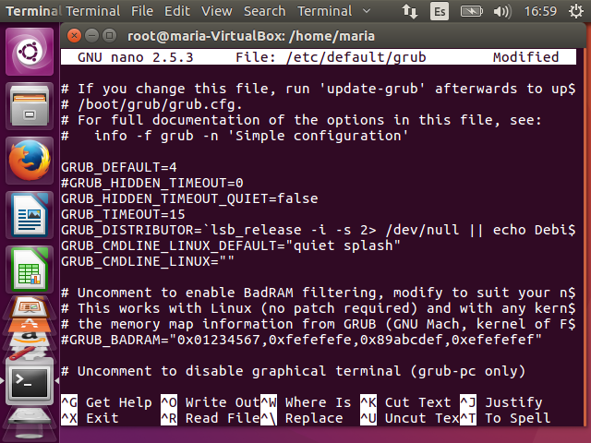

If is necessary to change the menu option you have to write update-grub and after that nano /boot/grub/grub.cfg and change there whatever you want.

In this exercise is not necessary to change the boot/grub/grub.cfg because menu is the default option

b)

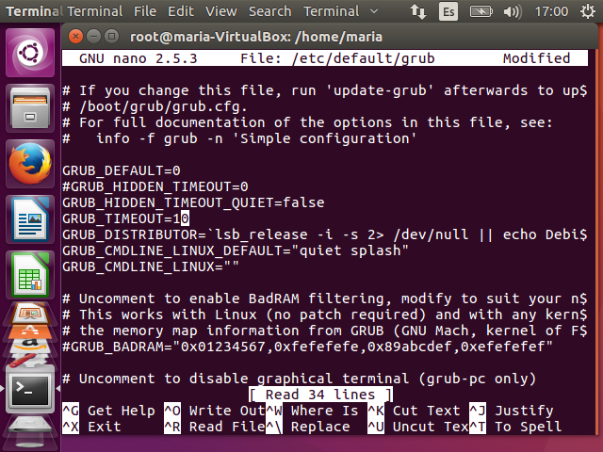

Now is necessary to change menu to countdown

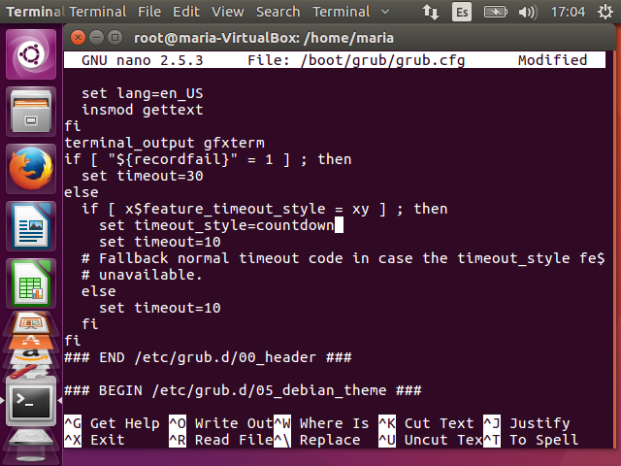

c) We have to follow the same step to change the default and timeout but now we have to put the timeout_style as hidden

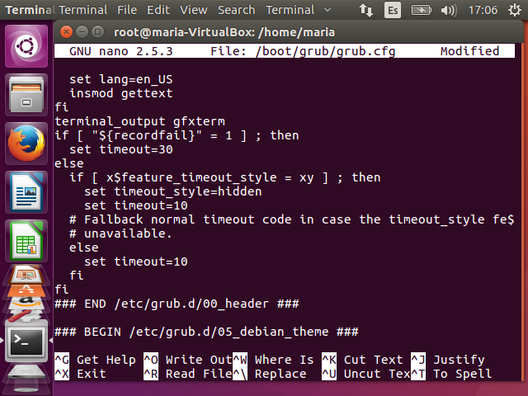

d) I repeat the same process again

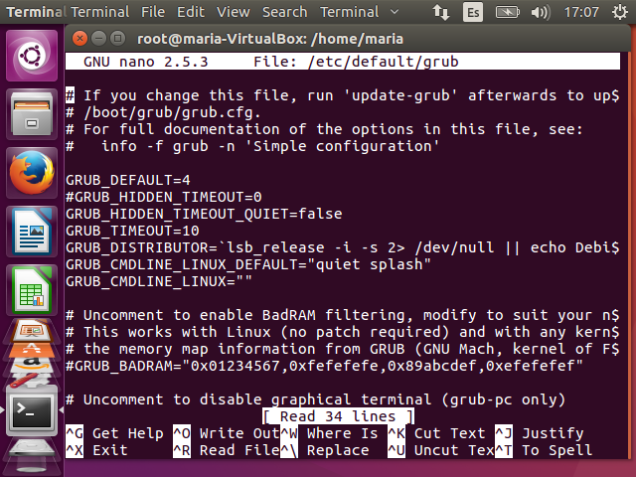

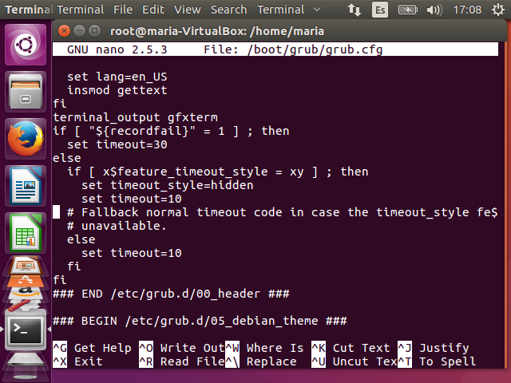

I don’t explain more deeply the process because I made it before.